Lab1:-

Question 1:-

print("Your Calculated Force is:", (float(input("Enter Mass: ")) * float(input("Enter Acceleration: "))))

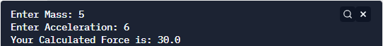

Question 2:-

print(input("Enter Your Name: ") + " is " + input("Enter Your Age: ") + " year old and lives in " + input("Enter Your Country: ") + ".")

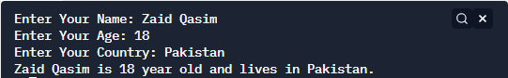

Lab 2:-

Question 1:-

import numpy as np

def insert(End_value,Start_value,value):

for i in range(End_value,Start_value,-1):

arr[i] = i - 1

arr[Start_value] = value

arr = np.array([input(f"Enter Player {i+1} Name: ") for i in range (int(input("How Many Player are there: ")))])

for x in range(len(arr)):

print(arr[x],end="")

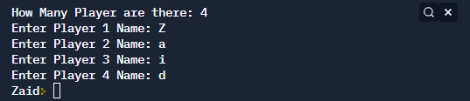

Question 2:-

import numpy as np

thislist = []

length = int(input("How Many Player are there: "))

value = input("Enter Value: ")

index = int(input("Enter Index: "))

arr = np.array(["" for i in range (length + 1)])

for i in range(length):

arr[i] = input("How Many Player are there: ")

for i in range(length):

thislist.insert(i, arr[i])

print("Given Array = ",thislist)

thislist.insert(index,value)

for i in range(4):

arr[i] = thislist[i]

print(arr)

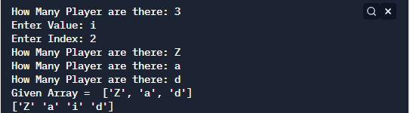

Question 3:-

import numpy as np

thislist = []

length = int(input("Enter Length: "))

index = int(input("Enter Index: "))

arr = np.array(["" for i in range (length)])

for i in range(length):

arr[i] = input("Enter Array: ")

for i in range(length):

thislist.insert(i, arr[i])

print(thislist)

thislist.pop(index)

arr[length-1] = ""

for i in range(length-1):

arr[i] = thislist[i]

print(arr)

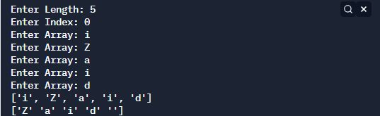

Lab 3:-

Question 1:-

from numpy import array

Array_1 = array([[0 for i in range(1,10)]for j in range(1,10)])

print(Array_1)

for i in range(0,9):

for j in range(0,9):

Array_1[i][j] = (i+1)*(j+1);

print()

print(Array_1)

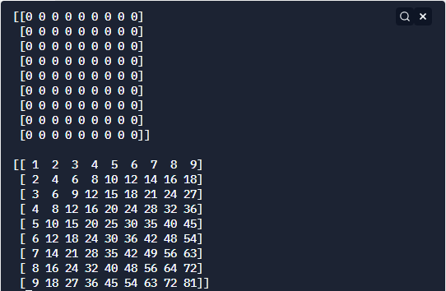

Question 2:-

from numpy import array

m1 = array([[1,2,3,4],[5,6,7,8]])

m2 = array([[1,2,3],[4,5,6],[7,8,9],[10,11,12]])

m = array([[0 for i in range(3)]for j in range(2)],dtype = object)

for i in range(2):

for j in range(4):

for k in range(3):

m[i][k] = m[i][k] + (m1[i][j] * m2[j][k])

print(m)



Question 3:-

from numpy import array

Array_1 = array([[1,2,3],[4,5,6],[9,8,9]])

Value = 0

Value0 = 0

for i in range(3):

Value = Value + Array_1[i][i]

t = 2

for i in range(3):

Value0 = Value0 + Array_1[i][t]

t = t -1

Value = Value - Value0

if Value < 0:

Value = -1 * Value

print(Value)



Lab7:-

Question 1:-

class Node:

def __init__(self, data):

self.data = data

self.next = None

self.prev = None

class LinkedList:

def __init__(self):

self.head = None

def PrintList(self, course):

temp = self.head

if(temp != None):

while (temp != None):

if(temp.data == course):

print("Your Course is:",temp.data)

print("Your Course's Prerequisites is: ",end="")

while(temp.prev != None):

temp = temp.prev

if (temp.prev != None):

print(f"{temp.data}",end=" | ")

break

temp = temp.next

print(temp.data)

else:

print("The list is empty.")

MyList = LinkedList()

first = Node("PF")

MyList.head = first

second = Node("OOP")

second.prev = first

first.next = second

third = Node("DST")

third.prev = second

second.next = third

fourth = Node("DBMS")

fourth.prev = third

third.next = fourth

fifth = Node("OOAD")

fifth.prev = fourth

fourth.next = fifth

sixth = Node("AI")

sixth.prev = fifth

fifth.next = sixth

seventh = Node("DP")

seventh.prev = seventh

sixth.next = seventh

MyList.PrintList(input("Enter Course You Want To Check: "))

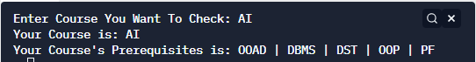

Question 2:-

class Node:

def __init__(self, data):

self.data = data

self.next = None

self.prev = None

class LinkedList:

def __init__(self):

self.head = None

def push_back(self, newElement):

newNode = Node(newElement)

if(self.head == None):

self.head = newNode

return

else:

temp = self.head

while(temp.next != None):

temp = temp.next

temp.next = newNode

newNode.prev = temp

def push_at(self):

nodeToDelete = self.head

self.head = nodeToDelete.next

self.head.prev = None

nodeToDelete = None

temp = self.head

while(temp.next != None):

temp = temp.next

temp = temp.prev

temp.next = 0

def PrintList(self):

temp = self.head

if(temp != None):

print("The list contains:", end=" ")

while (temp != None):

if (temp == 0):

break

else:

print(temp.data, end=" ")

temp = temp.next

print()

else:

print("The list is empty.")

MyList = LinkedList()

MyList.push_back(10)

MyList.push_back(20)

MyList.push_back(30)

MyList.PrintList()

MyList.push_at()

MyList.PrintList()



Lab8:-

Question 1:-

class Node:

def __init__(self, data):

self.data = data

self.next = None

class LinkedList:

def __init__(self):

self.start = None

def Push(self, value):

newNode = Node(value)

if(self.start == None):

self.start = newNode

return

else:

temp = self.start

while(temp.next != None):

temp = temp.next

temp.next = newNode

def Print(self):

temp = self.start

i = 1

if(temp != None):

while (temp != None):

print(f"{i}.",temp.data, end = " \t")

i = i + 1

temp = temp.next

else:

print("The list is now empty.")

print()

print()

def Pop(self):

temp0 = self.start

temp1 = temp0.next

if(temp0 != None):

while (temp1.next != None):

temp0 = temp0.next

if(temp0.data == self.start):

break

temp1 = temp0.next

temp0.next = None

print("Your Poped Item is:",temp1.data)

temp1.next = None

MyList = LinkedList()

MyList.Push(10)

MyList.Push(20)

MyList.Push(30)

MyList.Pop()

MyList.Pop()



Question 2:-

def Push(array, top, max, item):

if(top == max):

print("Sorry :( Your Stack is Full")

else:

top[0] += 1

array[top[0]] = item

def Pop(array, top):

item = 0

if(top[0] == -1):

print("Enter Elemet First")

else:

for x in range(top[0],-1,-1):

print(array[top[0]],end="")

array[top[0]] = 0

top[0] -= 1

max = int(input("Enter Number Of Element: "))

array = [0 for i in range(max)]

top = [-1]

for i in range(max):

Push(array,top, max-1, input("Enter Item: "))

print("Your Array in reverse Order is: ",end="")

Pop(array, top)

print()

